**Introduction**- This article is written by BBC climate editor JR. It is about climate change, particularly global warming impacts on Antarctician glacier.

**Body-** The author shared his impression and experience while he visited to the white continent- Antarctica. As a climate editor , he tried to get first- hand information on the extent of ice loss and overwhelming caused by human extensive activities and careless behaviour.

He expressed his admiration on greatness of white continent as a valuable guard of the world balance, as well as his deep concerns on losing this fragile treasure.

Given studies and figures also demonstrated continuing loss of overall ice rate and increasing land temperature last decades (sources: Satellite monitoring ; University of California Berkely).

**Conclusion**-Although the author was emotionally stirred and overwhelmed face to entirely loss of glacier , he ended his report with positive notes and hopes: believing and trusting high adaptability of human species , their innovating capacities and wisdom to reverse global warming trends and to tackle climate change consequences.

Climate reporting reaches melting point

**Source:A trip to a melting glacier will shape how the BBC's new climate editor, Justin Rowlatt, reports on the story of climate change.**

You cannot help but be awed by the scale of Antarctica, the great white continent.

I visited just before the pandemic struck and it is impossible not to feel humbled in the presence of something that seems so much bigger and more powerful than you.

But that sensation is an illusion.

When we finally flew over the front of the enormous glacier after weeks of travelling, I found myself staring down at an epic vision of shattered ice.

[**As I wrote at the time**](https://www.bbc.co.uk/news/stories-52066238), it felt like I'd reached the frontline of climate change; a place where the equilibrium that has held our world in balance for thousands of years was slipping and crashing.

Satellite monitoring shows that the overall rate of ice loss from West Antarctica has increased five-fold over a 25-year period. This one glacier - Thwaite's glacier - alone now accounts for 4% of global sea level rise.

Needless to say, this acceleration is a result of us humans polluting the air with greenhouse gases. That fact explodes any impression that the ice is overwhelming. The opposite is true, we are overwhelming the ice.

I was surprised how moved I was by what I'd seen. In the weeks it took to travel home, I tried to process my emotions.

I thought about the men and women who had set our camp, who flew the planes, cooked the meals, processed the rubbish and groomed the ice runways. And I thought about the scientists who have been studying the processes at work for decades.

Our research trip was only possible because of a huge chain of human enterprise culminating with the hardworking people in the UK and US whose taxes paid for it all.

As I flew back to the UK, I reflected how it is often claimed that selfishness, greed and conflict are the hallmarks of humanity, but that is wrong.

Taking control

The defining human characteristic is actually our ability to co-operate - our ability to solve problems together explains the dominance our species has achieved.

For the first time since I had been to the front of the glacier I began to feel the stir of something I was worried I'd lost entirely: a sense of purpose.

I retell this story now because I want that sense that we can come together and take control of the processes driving climate change to underpin my reporting in my new role as climate editor.

Of course, the BBC has been reporting climate change for decades and we'll be keeping up that tradition, especially during a crucial UN climate conference in Glasgow in November, where nations will be asked to renew their commitments to cutting emissions.

But however ambitious the deal there is, we need to continue to report the latest science on climate change and the effect it is having on our world.

And use that science as a yardstick to judge the progress our societies are making to reduce emissions.

That means scrutinising what politicians, business people and - yes - all of us consumers are doing to try to reduce our impact on the climate.

I do not want to nag or hector. We all face the same dilemmas over how the choices we make in our lives affect the climate.

And I am optimistic about what we can achieve.

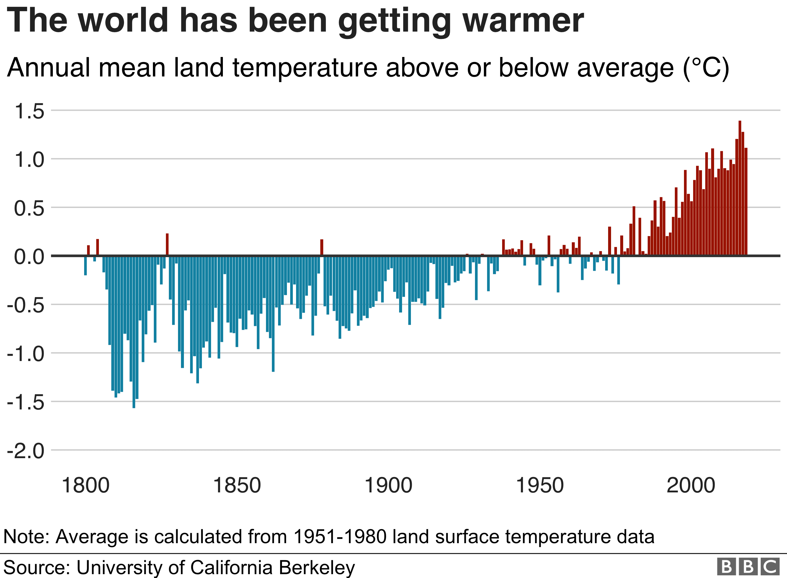

We humans are wary of change but we are actually extraordinarily adaptable - another key to our success as a species. And we have a vast capacity for innovation.

Think of the huge offshore wind industry flourishing here in the UK, or the way our car industry is retooling as the ban on new petrol and diesel vehicles approaches.

Look at the UK companies at the forefront of all sorts of exciting low-carbon technologies - from nuclear fusion to plant-based foods - and consider the fortunes to be made as these new markets go global.

And look at the progress being made to mobilise international finance behind the effort to tackle climate change - an endeavour being led by the City of London.

But I will not forget what I saw in Antarctica. It reminds us that climate change is a process that is likely to take centuries to play out, and tens of thousands of years to reverse.

Consider this: the last time CO2 levels were this high is reckoned to have been around four million years ago and it is estimated that the sea level then could have been as much as 30-40 metres higher than it is now.

That's a measure of how important the climate issue is and also explains why I'm so pleased to be given this opportunity to play a role in covering it for the BBC.

Tackling global warming will be the central project of the 21st Century and it is an incredible privilege to have been given a front row seat.

TO DO:

a)explain the meaning of highlighted words

b) write a report ( min .100 words- use correct methodology ).